Why Millions Are Downloading Game 21 Online – Join the Fun Now

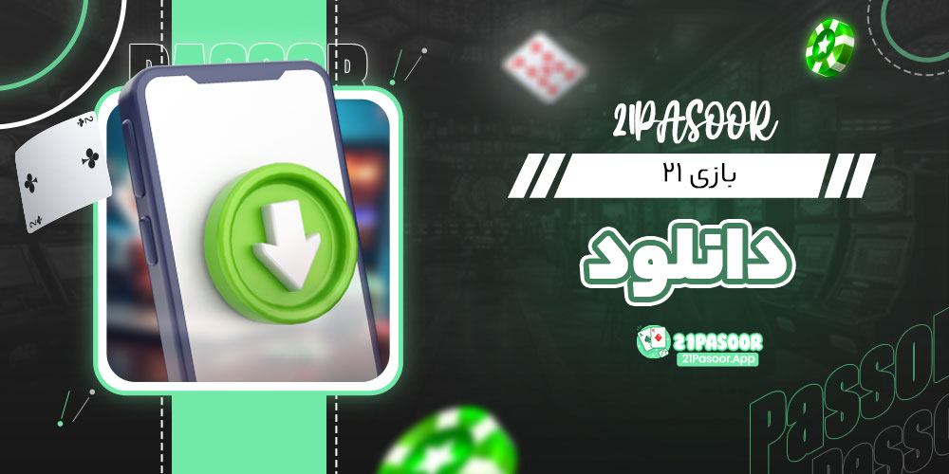

In the present quick moving world, individuals are continually looking for better approaches to partake in their available energy. The computerized age has made it simpler than at any other time to get to different games that can be played on-request, any place and at whatever point you need. Among the most well known games that keep on dazzling players is the exemplary 21 game. Whether you're hoping to loosen up following a difficult day or challenge companions, the capacity to download the game 21 on the web and play whenever, anyplace gives a remarkable and helpful experience. This article will investigate the intricate details of downloading the game, how to play, and why it has become such a staple in web based gaming networks.

What is the 21 Game?

The 21 game is a game, frequently alluded to as Blackjack when played in club, however the basic principles make it exceptionally open for all ages. The fundamental goal is direct - the player plans to arrive at a hand worth of 21 or as near it as conceivable without surpassing it. Players are managed two cards, and they can decide to "hit" to get more cards or "stand" to keep their hand. With key choices and a component of karma, the game can inconceivably invigorate.

The magnificence of the 21 game lies in its effortlessness. While it tends to be delighted in group environments with companions, the capacity to play it online has made it a #1 among relaxed players and serious gamers the same.

Why Download the Game 21 On the web?

The choice to download the game 21 web-based brings a variety of advantages. Here are a few key justifications for why players decide to play this game in a computerized design:

Availability

One of the fundamental benefits of playing the game 21 online is the capacity to get to it anyplace. Whether you're at home, voyaging, or holding up in a line, you can download the game and begin playing in no time. This adaptability causes it an optimal game for any time you to have a couple extra of seconds.

Play Whenever

Dissimilar to actual games, the internet based form permits you to play whenever of the day or night. Whether it's an offhand game during your mid-day break or a late-night meeting, the internet based variant is dependably good to go.

Assortment of Stages

You needn't bother with to be restricted to one gadget. The game 21 can be downloaded on various stages, including cell phones, tablets, and work stations. Whether you incline toward iOS, Android, or Windows, you can without much of a stretch access and partake in the game on your favored gadget.

Single or Multiplayer Mode

Contingent upon the stage, you can decide to play solo against the man-made intelligence or challenge your loved ones in multiplayer mode. This adaptability takes into consideration a customized gaming experience. Whether you need to work on your abilities or have a cutthroat game evening, the web-based variant conveys the full insight.

Moment Updates and Highlights

By downloading the game 21 on the web, you're[بازی ۲۱ ایرانی](https://21pasoor.app/) guaranteed of getting refreshes and new highlights when they become accessible. This constant advancement guarantees the game stays crisp, offering new moves and upgrades to improve interactivity.

Instructions to Download the Game 21 On the web

Beginning with the game 21 online is a direct cycle. Here is a bit by bit manual for help you download and begin playing the game:

Pick Your Foundation

Begin by choosing the stage that best suits your gadget. Most game 21 applications are accessible for iOS, Android, and PC. You can look the particular application stores or visit believed gaming sites for the authority game download.

Download the Application or Game Record

Subsequent to picking the stage, click on the download interface. On the off chance that you're on a cell phone, it will guide you to the application store for a simple establishment process. On a PC, you may be approached to download the game document straightforwardly from a site. Guarantee you are downloading from a dependable and trustworthy source.

Introduce the Game

Once the download is finished, adhere to the establishment guidelines on your gadget. The cycle normally includes consenting to the application's agreements, then clicking introduce. It normally just takes a couple of seconds for the game to be prepared.

Open and Play

When the game is introduced, send off it from your home screen or application menu. Contingent upon the stage, you might have to make a record or sign in before you start playing. A few games likewise offer a visitor mode in the event that you like to begin quickly without enlisting.

Figuring out the Principles of the 21 Game

While the principles of the 21 game are easy to get a handle on, dominating them requires practice and methodology. The following is an outline of how to play the game:

Card Values

Number cards (2-10) merit their assumed worth.

Face cards (Jack, Sovereign, Ruler) are worth 10 focuses each.

Pros can be worth either 1 or 11 focuses, contingent upon which worth advantages the player's hand more.

Game Stream

Toward the start of the game, every player is managed two cards. You can then choose whether to "hit" (take another card) or "stand" (keep your ongoing hand). You can continue to hit until you arrive at a hand worth of 21 or go over, which is classified "busting." On the off chance that you bust, you lose the round. The objective is to arrive at 21 focuses without surpassing it.

Winning Circumstances

On the off chance that your hand esteem is nearer to 21 than the seller's hand (in multiplayer mode), you win the round. In the event that the two players have a similar hand esteem, it's viewed as a tie or a "push." The player wins on the off chance that they have a hand all out of precisely 21 focuses.

Extraordinary Elements

A few internet based variants of the game present extraordinary highlights like "multiplying down" or "dividing matches," adding key layers that take into consideration further developed play.

Tips and Systems for Playing 21 On the web

While 21 is principally a toss of the dice, utilizing essential methodologies can work on your chances of winning. The following are a couple of techniques to remember while playing the game:

Know When to Hit or Stand

One of the vital choices in 21 is whether to hit or stand. An overall procedure is to hit in the event that your hand is 11 or less and stand assuming your hand is at least 17. In the event that you have a hand esteem between 12-16, you ought to think about the seller's face-up card and choose as needs be.

Grasp the Vendor's Way of behaving

In numerous web-based variants of 21, the vendor should keep a severe guideline set. For instance, the seller could need to hit in the event that they have a hand worth of 16 or less and stand on 17 or higher. Monitoring the seller's way of behaving can assist you with settling on informed conclusions about when to hit or stand.

Stay away from the Gamble of Busting

Assuming your hand is as of now 16 or higher, the gamble of busting becomes more noteworthy with each extra card you take. Think about this prior to hitting, as in some cases remaining on a lower hand can be more key.

Careful discipline brings about promising results

Since 21 is a game that consolidates karma and expertise, it means a lot to rehearse. Play frequently and try different things with various procedures to work on your possibilities. Online stages offer the upside of free practice modes, where you can play without gambling any cash.

Advantages of Playing 21 On the web

The advanced world has opened up new roads for playing exemplary games like 21. Here are a portion of the key advantages:

Accommodation

The internet game can be played whenever and from practically anyplace. Whether you have five minutes or 60 minutes, you can partake in the game without the need to set up an actual table or assemble a gathering.

Assortment of Game Modes

With different internet based stages offering multiplayer, single-player, competition, or even live seller choices, there's something for everybody. You can partake in a relaxed game or participate in more serious play with other web-based members.

Availability for Amateurs

The internet based adaptation frequently incorporates instructional exercises, tips, and practice modes, making it more straightforward for new players to gain proficiency with the guidelines and procedures of the game. This availability permits players of all expertise levels to appreciate 21.

End

Downloading and playing the game 21 online has never been more straightforward. Whether you're hoping to breathe easy, work on your abilities, or challenge companions, the advanced configuration permits you to do as such effortlessly. With its straightforward standards, energizing ongoing interaction, and vital profundity, it's no big surprise that the 21 game keeps on being a dearest decision for a great many players around the world. All in all, why pause? Download the game 21 internet based today and begin playing whenever, anyplace!